**File Sharing Feature**

An integral part to the site is a file uploading feature in order for members of projects to upload their files as they progress through their projects. The user will click the option to upload a file and then be prompted to search through their computer files and select a file. Once the user has selected the file they need to upload they will be able to upload it, or select more files to upload. After all files are selected they would click the upload button and their files will be added to the database and be available for viewing by user, and other members in their project team.

This feature will also provide an option for a user to decide who can view their file if they wanted to put a restriction on it of some sort, or, even make it public to other registered users on the site. This option includes an option for restricting access to the file to everyone (including team members) except the user who uploaded the file. Users will be able to view all of their files and manage them (update, modify, remove and change who can view).

* How to manage who can update files (if they are working on the same file)

**Database Tables: User Uploads**

|  |  |
| --- | --- |
| Id | INT Not Null |
| username | VARCHAR(30) |
| ProjectID | INT(15) |
| Title | VARCHAR(30) |
| Description | VARCHAR(255) |
| FileName | VARCHAR(30) |
| File Size | INT 11 |
| Created | Date |
| Modified | Date |
| FilePath | VARCHAR(60) |

**Dataflow**

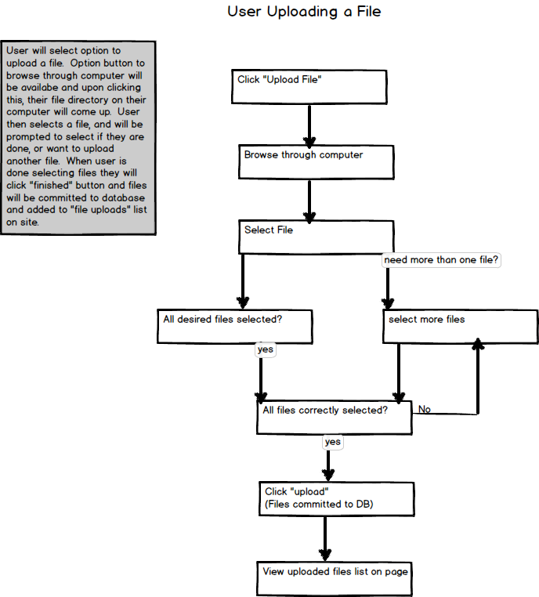

Users may choose to upload files to share on the site. The user will select “Upload File” and will be prompted to browse through their computer and select the file they wish to upload. The user can then decide if they want to add more files, and ensure all files they want have been selected. After all desired files have been selected the user will click “Upload” and the files will be added to the database and will be viewable on the View uploaded files page.

**User Deleting A File**

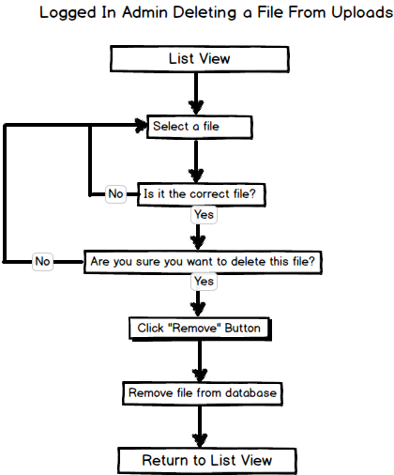

A logged in user can function as an admin within this feature, in order to maintain their file uploads. They have the option to remove files they have uploaded and would begin by reviewing the list view of uploaded files. The admin will select a file to delete, ensure it is the right file, and be promted to confirm whether they wish to delete the file or not. If the admin were to decide to cancel instead of delete a file they will return to list view to select a different file. When admins do confirm they want to delete a file they will hit the “Remove” button and upon confirmation the file will be removed from the database and the admin will return to list view.

**WireFrames:**

**These are from my other php project, but are a general idea of how this feature will be structured so I included them.**

File Upload

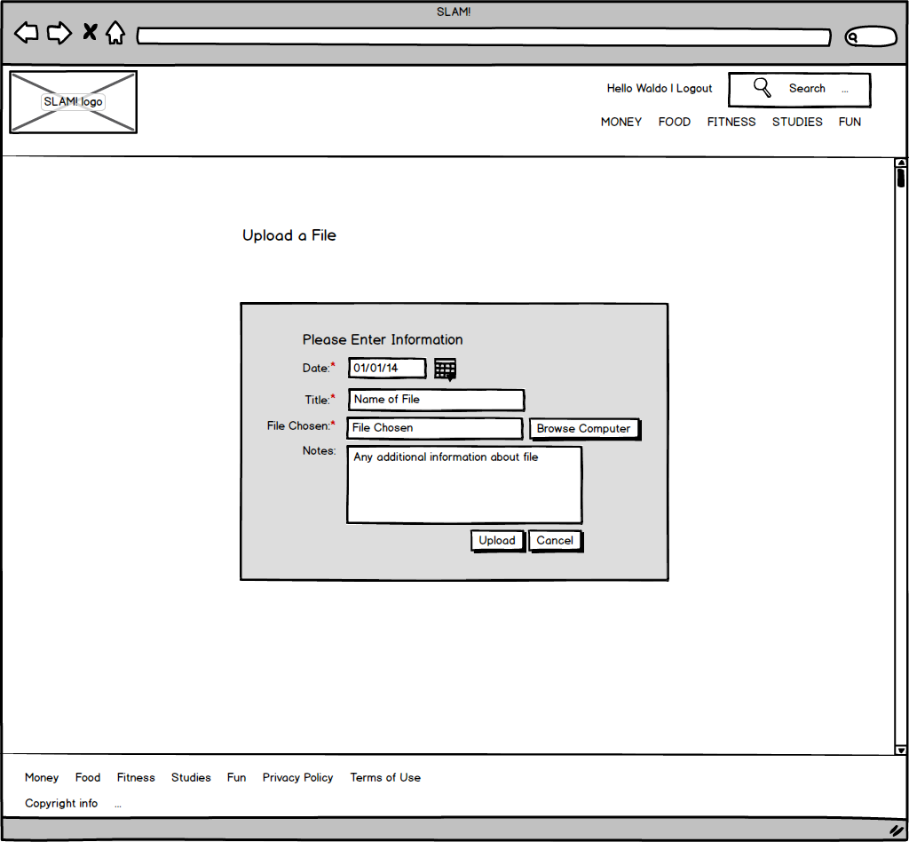

Logged In User View of File Uploads

This wireframe will have the addition of a “download” option.

